Wakefield Civic Society Environment Enhancement Awards 2026

Entry Form
The award is open to any individual, business or organisation but we particularly welcome entries from community groups, youth groups and schools but please note that we will not consider nominations for projects that have previously been recognised with one of our awards.
All entries must be for projects or initiatives based within the area covered by Wakefield Civic Society, that is to say the area defined by Wakefield City and adjoining areas but not other towns in the District. Please consult our map to see the area we cover if in doubt.
The closing date for receipt of your entry form is Friday, 13th February 2026.
(Text Boxes below will expand as you type.)

Q1: Details of person submitting the entry

Name of contact:
Position/ Post Held:
Organisation:
Full Correspondence Address:
E-mail Address:
Telephone Number:
Mobile Number:

Q2: Name of project or initiative (15 words maximum)

Q3: Summary of your project (250 words maximum)
(State the context, scope, intended beneficiaries, working methods and achievements so far)
Q4: Please state which of the following criteria are relevant to the nominated scheme.
(One or more criteria must be specified.)
Mark each answer with an X

Better recycling & waste management.
The promotion of biodiversity, habitat creation & protection.
Community-based campaigns and measures in favour of carbon reduction and sustainable consumption.
The prevention of litter & pollution, including air and water pollution.
The promotion of sustainable travel arrangements such as walking, cycling and public transport.
The provision of environmental education and the raising of environmental awareness
Measures to improve the environment such as planting schemes, reclamation of open spaces, tidying and clearance of waterways, etc.

Q5: Written justification for award.
Explanatory notes:

Entries will be assessed on evidence of
- Originality,
- The actual or likely impact on the environment
- Potential for community benefit
- Evidence of good leadership in championing the environment and in engaging and inspiring others.
- Evidence of further potential and future development is desirable but not essential.
- Evidence of further potential and future development is desirable but not essential.
Answer as many of the following questions as possible.
- How did the project or initiative depart from previous practice? Was there any innovative or original aspects?
- Who or what has benefited?
- What has the project or initiative achieved? Has the project or initiative achieved more or less than expected?
- How many people has your project involved? If an educational initiative, how many people has it reached?
- With which other organisations has your organisation worked in designing and delivering the project?
- Can other organisations both in Wakefield and elsewhere benefit from implementing your methods?
- What have you learnt and what do you propose now?
Include photographs, maps and publicity material if these are available. If submitting photographs, please ensure that all individuals featured have given their consent for the photos to be submitted to us in the knowledge that we may use the photos in print or on-line. Please provide the name of any individual or organisation whom we should credit if we should use the photos you supply.
There is no word limit. The box below will expand as you type.

Declaration by nominee
Where this form has been completed by someone other than the nominee, we ask that the person being nominated, or a representative of the organization being nominated, confirm here that they wish the nomination to go forward for the Wakefield Civic Society Environment Awards.
I have read the details in this completed form and can confirm their accuracy to the best of my knowledge.
Type your name here:
Please provide your contact details below.

Name of Nominee:
Position/ Post Held:
Organisation:
Full Correspondence Address:
E-mail Address:
Telephone Number:
Mobile Number:

Please confirm by ticking this box that that you have the permission of any individuals featured in photos submitted as evidence to support your entry and that they consent in the knowledge that the Society might later use the images on-line or in print to promote the awards | Yes/No
Do we need to give credit/acknowledgment for any of the photos you are including in your entry should we decided to use them in print or on-line to publicise the award?  Please enter below the details of any credits or acknowledgements we should add to any photographs you submit should we decide to use them in print or on-line: | Yes/No

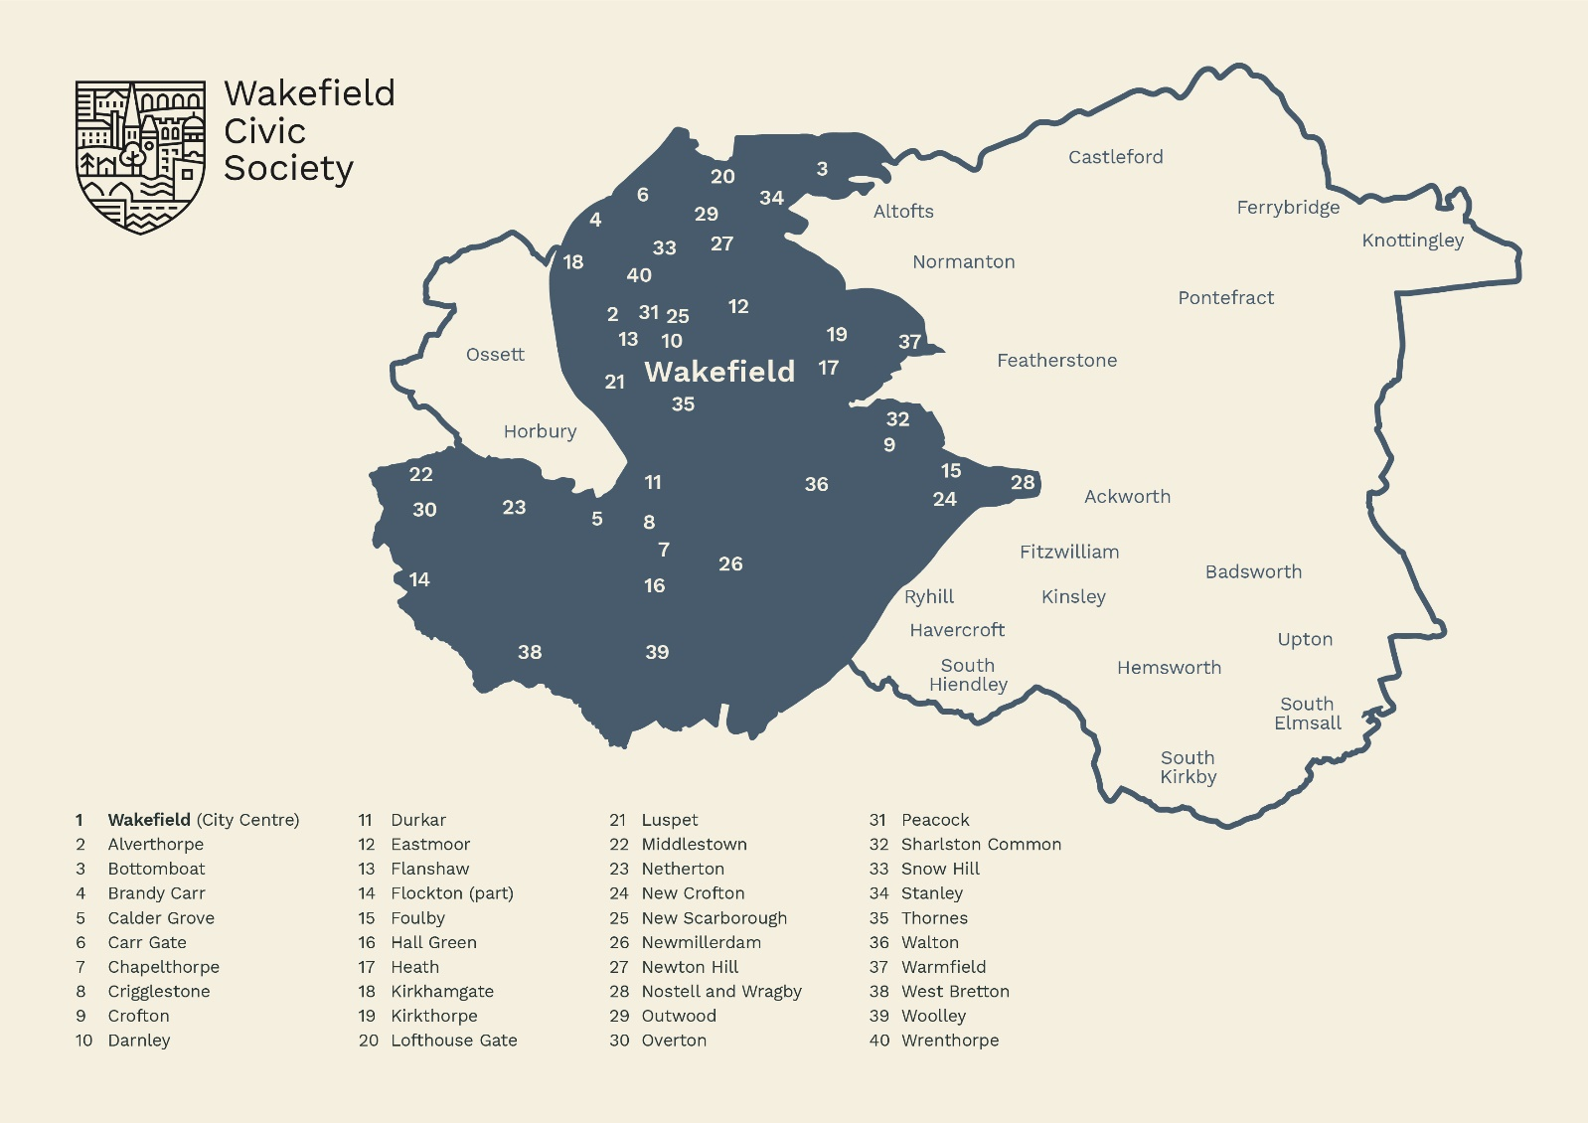

The Society’s area is that shaded grey above.

